- Problem and Data
1.1. Task definition
Gate5 is a conversational travel planner that turns a short trip request into a realistic, editable day-by-day itinerary. For the first version, the system handles one city per trip and trips of 1-3 days. The user describes the trip in natural language (city, dates, interests, travel pace, approximate budget), and the system returns a schedule made only of places that exist in a curated local dataset. The user can then ask for a change, for example replacing one stop, and the system updates only the affected day while keeping the rest of the plan unchanged.

Some of the problems we identified while completing our RFC were: the planning taking too much time, AI may invent places and a single activity should not force the user to regenerate the whole trip.

Gate5 does not book anything, guarantee opening hours or prices, or monitor live incidents. When information is missing or uncertain, the system marks it as unknown instead of guessing.

1.2 Data sources

Source/storage | What it contributes | Limitation
OpenTripMap and/or OpenStreetMap | Real place records: provider ID, name, coordinates, category, source link, sometimes opening hours | Completeness varies by city: IDs from different providers are not interchangeable
Local SQLite/JSON cache | Reproducible candidate list for one curated city, used by the demo, tests and golden dataset | Must store data origin and retrieval date; can become outdated
Travel guides (Wikivoyage), curated travel blogs/articles, and community threads (Reddit JSON API) | Narrative context for RAG: neighborhoods, getting around, culture, local blog recommendations, rainy-day tips, and common scams/cautions | Not authoritative for live opening hours or live incidents; blog and forum opinions require source attribution
Optional weather provider (e.g. Open-Meteo) | Forecast-based indoor alternatives for supported dates | Forecast window and service availability to be verified; added only if the core flow works

Principle: venue identity, coordinates and hours come from the structured place data; RAG text only explains the context. The language model selects among stored records and never creates venue IDs.

For the first demo, we plan to curate roughly 25-40 well-known places in one city. We consider a small reliable dataset more valuable than a large noisy one. Actual coverage and data quality are to be tested during implementation.

1.3. Place schema
Each place is stored in a normalized format that is shared with the agent and validator. The format used is JSON.

{
"provider": "opentripmap",
"provider_id": "<id from provider>",
"name": "<place name>",
"city": "Rome",
"category": "museums",
"interest_tags": ["history", "indoor"],
"lat": 41.0000,
"lon": 12.0000,
"source_url": "<link to provider record>",
"opening_hours": null,
"hours_status": "unknown",
"est_visit_minutes": 60,
"retrieved_at": "2026-11-xx"
}

1.4. Missing and uncertain data policy
Opening hours are not always available. We represent them with an explicit hours_status field:
- Known: structured hours exist, with source and retrieval date;
- Unknown: no reliable hours, the UI shows “hours not verified” -> the validator can not claim a conflict-free schedule anymore.
Visit duration and walking time are estimates (conservative distance-based calculation) and are labelled as such. Missing values are never replaced with invented ones.

1.5 Ingestion of new data
Ingestion is a simple, repeatable script rather than a live data pipeline.
Structured places:
- Download or manually curate a small set of places for a city.
- Normalize them to the Place schema.
- Store them with provider, provider_id, source link and retrieved_at.
- When new or updated records arrive, insert or update by (provider, provider_id), so reruns do not create duplicates
Guide text for RAG:
- Collect legally usable guide pages and keep the attribution and license information.
- Split them into short passages (chunking details are described in the RAG section)
- Attach metadata: city, topic, source URL, updated_at.
- Embed the passages and upsert only new or changed ones into the vector store.

Adding a new city: run the same scripts with a new city name or configuration (place list + guide documents). No change to the agent or tools is required, because they read from the same schema. A new city is accepted only after its place records and a few test cases pass the same checks as the first city.

A place being in our dataset means that it has a stored provider ID and source, which reduces hallucination risk, but id does not guarantee that the business is currently operating. Free APIs may limit requests, so the demo uses cached data with explicit data-date labels.

2. Golden Dataset

2.1. Purpose and approach
To evaluate Gate5, we plan to create a Golden Dataset, a collection of representative user requests together with the expected behavior of the chatbot.
The goal is to test whether Gate5 can generate realistic itineraries, respect user preferences, recommend places from our curated dataset, and modify existing plans correctly. We also want to evaluate how the system handles missing information and whether its travel advice is supported by reliable sources.
Since travel planning is subjective, there is not always one correct answer. For example, two different itineraries for Rome might both be useful, even if they recommend different attractions. Therefore, instead of expecting an exact answer, we will define conditions that a successful response should satisfy.
For the initial version, we propose creating approximately 20–30 test cases, focusing on the single city supported by our prototype. This should provide enough variety to test the main features without making the evaluation unnecessarily complicated.

2.2. Dataset creation and structure
We will create the test cases manually, using the scenarios identified in our RFC and real records from the curated place dataset described in Section 1.
We will include both normal requests and situations where the chatbot might make mistakes, such as suggesting too many activities, scheduling a closed attraction, or changing parts of an itinerary that the user wanted to keep.
Each test case will contain:
Field | Description
Test ID | Unique identifier, such as GD01
User request | The message sent to the chatbot
Test context | Relevant information, such as an existing itinerary or known opening hours
Expected behavior | What the chatbot should do
Validation criteria | Conditions used to determine whether the response is correct
For tests involving itinerary modifications, we will provide the original itinerary so that we can compare it with the updated version. For tests involving opening hours, we will use places whose availability information is known or explicitly marked as unknown.
We plan to store the cases in JSON or CSV format, so they can be reused for testing different models and system configurations. We will also record which version of the local place dataset was used during each evaluation.

2.3. Representative test cases
We will organize our tests into five categories: itinerary generation, schedule realism, itinerary modification, missing information, and RAG-based travel advice.
The following examples use Rome as an illustrative destination. They will be adapted to the actual city and attractions selected for our prototype. Where trip details are not included in the request, they are assumed to be provided in the test context.
ID | Category | Example user request | Expected behavior
GD01 | Itinerary generation | "Plan a two-day trip to Rome. I like history and local food, and I prefer a balanced pace." | Generate a two-day itinerary with relevant attractions, reasonable visit durations, and time for travel and breaks.
GD02 | Itinerary generation | "I have four hours in Rome and want a relaxed, inexpensive afternoon." | Recommend a small number of suitable activities that fit the available time and budget preferences, without inventing prices.
GD03 | Schedule realism | "Can you fit six museums into two hours?" | Recognize that the request is unrealistic and suggest a more practical alternative.
GD04 | Schedule realism | "I want to visit this museum on Monday morning." | If stored opening hours show the museum is closed, suggest another time or attraction instead.
GD05 | Schedule realism | "Can I visit this attraction at 9 AM?" | If opening hours are unknown, explain that they cannot be verified rather than inventing them.
GD06 | Itinerary modification | "Replace my afternoon outdoor activity with something indoors. Keep the morning unchanged." | Select an indoor alternative from the dataset, update the affected schedule, and preserve unrelated activities.
GD07 | Itinerary modification | "Day 2 is too busy. Make it more relaxed without changing Day 1." | Reduce or reorganize Day 2 activities while leaving Day 1 unchanged.
GD08 | Missing information | "Can you plan a trip for me?" | Ask for essential missing details, such as destination and trip duration, before generating an itinerary.
GD09 | Missing or unreliable data | "Add this attraction to my itinerary." | If the attraction cannot be found in the stored dataset, explain that it could not be verified rather than inventing a place record.
GD10 | RAG-based advice | "What should I know about getting around the city?" | Give useful information based on retrieved travel-guide content, with source references and no unsupported claims about current schedules or prices.
These examples cover the main functionality of our prototype. We will expand them into the planned 20–30 cases by varying preferences, trip durations, available attractions, and existing itineraries.
We will also include cases that test the system's limitations. For example, since Gate5 does not monitor live incidents, it should explain that it cannot verify current strikes or disruptions instead of making unsupported claims.
Weather-related tests may be added separately if we implement that optional feature.

2.4. Evaluation methodology
We plan to combine automatic validation with a small amount of manual evaluation.
Automatic checks will focus on requirements that can be objectively verified:
- Place grounding: Every recommended attraction should match a stored record using its provider and provider_id. This reduces invented recommendations, although it does not guarantee that a place is currently operating.
- Schedule validity: Activities should not overlap, and the itinerary should account for estimated visit durations and travel times.
- Opening-hour consistency: Known opening hours should be respected. When hours_status is unknown, the chatbot should acknowledge the uncertainty rather than claim the visit is confirmed.
- Modification correctness: Unrelated days and activities that the user explicitly wants to preserve should remain unchanged.
- Information reliability: The chatbot should not invent prices, opening hours, or live travel information.
- RAG grounding: Answers based on travel-guide documents should be supported by relevant retrieved passages and include source references.
Not every check will apply to every test case. For instance, a question about transportation advice does not require itinerary schedule validation.
Some aspects, such as how useful or understandable an itinerary is, are harder to evaluate automatically. For these, we will use a simple manual scoring system:
Criterion | Score | What we evaluate
Relevance | 1–3 | Does the response respect the user's request and preferences?
Practicality | 1–3 | Is the itinerary or advice reasonable and useful?
Clarity | 1–3 | Is the response understandable and easy to follow?
For each criterion, 1 = poor, 2 = acceptable, and 3 = good, giving a maximum manual score of 9 points.
We will keep manual scores separate from automatic validation results. An itinerary might sound convincing but still fail an essential requirement, such as recommending an attraction that does not exist in our dataset.
A test will pass when all its applicable mandatory checks are satisfied. Manual scores will help us compare the quality of otherwise valid responses.

2.5. Evaluation example and expected results
Consider a user who already has a two-day itinerary and asks:
"Replace my outdoor activity on Day 2 with an indoor attraction. Keep everything else the same."
For this test, we provide the original itinerary and at least one suitable indoor attraction from our curated dataset.
We then check the following:
Validation criterion | Expected result
Unchanged activities | Day 1 and the morning of Day 2 remain unchanged
Activity replacement | The outdoor activity is replaced with an indoor alternative
Place grounding | The replacement matches a stored place record
Schedule validity | The updated activities do not overlap
Opening hours | Known closed hours are respected, and unknown hours are identified
Response clarity | The chatbot briefly explains what was changed
If the chatbot changes Day 1 unnecessarily or introduces an attraction that cannot be found in our dataset, the test fails the corresponding mandatory check, even if the generated itinerary sounds reasonable.
This example shows why we need to evaluate both the generated response and the structured itinerary.

Using the evaluation results
We will use the same Golden Dataset to test improvements and compare different implementation choices. For each run, we plan to record the test ID, system configuration, generated response, validation results, manual score where applicable, and any important failures.
To make comparisons meaningful, we will keep the test inputs and place dataset version consistent. We also intend to reserve a small subset of cases for final evaluation rather than repeatedly using every case during development.
The results will help us identify whether problems come from the language model, the place data, the itinerary planning logic, or the RAG component.
We will summarize the evaluation using the percentage of applicable tests passed, average manual scores, and examples of common failures.
Our goal is not to prove that Gate5 can always produce a perfect itinerary, but to establish a simple, repeatable way to measure its reliability and demonstrate whether our implementation choices lead to improvements.

3. RAG Design

3.1. Role of RAG and architectural separation
In Gate5, Retrieval-Augmented Generation (RAG) provides the unstructured, narrative travel knowledge that complements our structured place database. To prevent hallucinations, we enforce a strict separation of responsibilities between our two data stores:
- Structured Place Cache (SQLite / JSON): Remains the sole authority for venue identity (provider_id), geographic coordinates, categories, and known opening hours.
- RAG Vector Store (Unstructured Text): Answers contextual, qualitative, and practical travel questions—such as neighborhood atmosphere, public transit rules, cultural dress codes, rainy-day strategies, hidden-gem blog tips, and common tourist scams or traps—and enriches itinerary explanations with sourced local context.

RAG is never used to invent venue IDs, guess geographic coordinates, or override schedule validation rules. Every RAG-assisted answer attaches provenance metadata (source title, URL, source type, and retrieval date) so the user can see whether advice comes from an official travel guide, a travel blog, or a community forum.

3.2. Knowledge base sources and extensible ingestion
Relying solely on a single encyclopedic guide page would limit the assistant to generic summaries and miss the practical, street-level advice identified in our RFC (such as local food spots, avoiding tourist traps, or adjusting plans for bad weather). Therefore, our RAG ingestion pipeline is designed to be source-agnostic and supports three categories of free text sources—allowing us to easily ingest Wikivoyage guides, arbitrary travel blogs or web articles, and Reddit community discussions—plus an optional live web search fallback:
Source Type | Source Examples & Cost | What it Contributes | Automated Ingestion Method
Structured Travel Guides (official_guide) | Wikivoyage city & district guides, public tourism portals (Free / open access) | Reliable overview of neighborhoods, getting around (metro/bus ticket rules), cultural etiquette, and general safety. | Automated Python script fetching structured article sections via the free MediaWiki / Wikivoyage API.
Travel Blogs & Web Articles (travel_blog) | Curated travel blogs, local city guides, and thematic articles (Free web pages) | Curated itinerary inspiration, neighborhood food guides, rainy-day indoor recommendations, and insider tips. | Automated web-article extractor using free open-source libraries (trafilatura / BeautifulSoup) to strip HTML boilerplate/ads and convert any blog URL into clean Markdown with headings.
Community Travel Discussions (community_forum) | Public Reddit travel threads such as r/ItalyTravel and r/rome (Free public JSON endpoints) | Real traveller experiences, honest crowd/wait-time warnings, and common local scam alerts. | Automated script querying public Reddit search JSON endpoints (sort=top) for targeted queries (e.g., Rome tips, Rome scams, Rome rain), filtering by minimum upvote score.
Live Web Fallback (Optional / Stretch) (web_search) | Tavily Search API (Free tier: 1,000 searches/month per key, exposed via MCP) | On-demand retrieval when local vector similarity is below threshold or for newly emerging travel questions. | Invoked dynamically at runtime when local retrieval confidence is insufficient; external results are explicitly labeled.

3.3. Chunking strategy and baseline comparison
Because our corpus combines long-form articles (Wikivoyage guides and travel blogs) with conversational Q&A forum threads (Reddit), naive character splitting would break context—for example, separating a paragraph about ticket validation from its "By Metro" heading in a guide or blog post, or separating a forum reply from the question it answers.
We will implement and compare two chunking strategies:

Primary Approach — Source-Aware Structural Chunking: For long-form articles (Wikivoyage guides and extracted travel blogs), we use Heading-Aware Recursive Splitting. HTML/Markdown articles are first split along section headings (H1/H2/H3, e.g., Get around, Best Rainy Day Activities, Where to Eat). Sections exceeding 300–400 words (~1,500–2,000 characters) are recursively split by paragraph and sentence boundaries with a 50-word overlap (~15%). Crucially, we prepend a hierarchical header breadcrumb (e.g., [City: Rome | Source: travel_blog | Section: Rainy Day Guide > Indoor Markets]) directly into each chunk before embedding so every passage remains self-contained. For community forum threads (Reddit), we use Post + Top-Comment Grouping, pairing each high-scoring top-level comment with the original post title and topic tag ([City: Rome | Thread: Common tourist scams near Colosseum]) so semantic context is preserved.

Baseline for Comparison — Naive Fixed-Size Chunking: All documents (guides, blogs, and threads) are split into flat 300-word windows with a 50-word overlap, ignoring HTML/Markdown section headings and thread boundaries. Comparing this baseline against our structural chunking allows us to measure whether preserving section headers and Q&A context improves retrieval precision and reduces out-of-context answers on our Golden Dataset.
Every chunk stored in the vector database follows a unified JSON metadata schema aligned with Section 1.5 (allowing any new guide, blog URL, or forum thread to be indexed seamlessly):
{
"chunk_id": "rome_blog_rainy_day_02",
"city": "Rome",
"topic": "rainy_day",
"section_path": "Rome Rainy Day Guide > Indoor Markets",
"source_type": "travel_blog",
"source_url": "https://example-travel-blog.com/rome-in-the-rain",
"updated_at": "2026-11-xx"
}

3.4. Embedding models
To ensure Gate5 runs at zero cost on team laptops without paid proprietary APIs, we use free, open-source embedding models from the HuggingFace sentence-transformers library (Apache 2.0 / MIT licensed) and will compare two candidates:
Fast Baseline — sentence-transformers/all-MiniLM-L6-v2 (384 dimensions): An extremely lightweight (~80 MB) model that runs rapidly on standard laptop CPUs, making it ideal for fast local indexing, unit testing, and baseline retrieval.
Primary Candidate — BAAI/bge-base-en-v1.5 or BAAI/bge-m3 (768 / 1024 dimensions): Open-source BGE models provide stronger semantic retrieval accuracy on asymmetric query-to-passage matching. In particular, bge-m3 (or multilingual MiniLM) better captures local non-English proper nouns, Italian transit and culinary terms (ATAC, ZTL, Termini, Trastevere, Supplì), and informal blog/forum phrasing.

3.5. Vector database choice
We will use ChromaDB (open-source, Apache 2.0 license) running in local persistent mode (PersistentClient storing index files directly in the repository data directory).
Zero-cost, serverless reproducibility: ChromaDB runs embedded inside Python with no paid cloud subscription or complex external server setup required, allowing every team member to run the exact same vector index locally.
Native metadata pre-filtering: Supports filtering by city, topic, and source_type (e.g., where={"city": "Rome"}) prior to similarity search, preventing cross-city contamination as new cities or blog sources are ingested.
Deterministic incremental updates: Supports upsert operations keyed by chunk_id, allowing the ingestion script from Section 1.5 to add new blog URLs or update modified guide passages without creating duplicate entries.

3.6. RAG approaches, SLM integration, and planned comparisons
When the agent calls the search_travel_notes(city, query, topic) MCP tool, the RAG pipeline retrieves relevant passages and returns them with source metadata. We will implement a simple dense retrieval baseline first and compare it against a two-stage hybrid retrieval pipeline:
Approach A (Baseline) — Metadata-Filtered Dense Retrieval (Top-k): Pre-filters chunks by city (and optional topic), computes cosine similarity between the embedded user query and stored chunk vectors, and returns the top k = 4 chunks.
Approach B (Proposed Approach) — Hybrid Search (Dense + BM25) with Cross-Encoder Reranking: In Stage 1 (Hybrid Candidate Generation), we combine dense vector search (top 10) with sparse keyword search using rank_bm25 (top 10) via Reciprocal Rank Fusion (RRF). Travel queries frequently contain exact proper nouns, pass names, or station names (e.g., "Roma Pass", "Leonardo Express", "Pantheon dress code") that pure vector search can blur, whereas BM25 captures exact terms and dense search captures broader semantic meaning across guides and blogs. In Stage 2 (Cross-Encoder Reranking & Thresholding), the merged candidates are rescored using a lightweight, free local cross-encoder (cross-encoder/ms-marco-MiniLM-L-6-v2) to select the top k = 3–4 passages above a minimum relevance threshold.
Confidence Threshold & Fallback: If no retrieved chunk exceeds the relevance threshold, the tool returns an explicit "insufficient_local_context" status rather than feeding irrelevant noise to the language model. The agent then either states that the information cannot be verified from local sources or optionally invokes the Tavily web search MCP tool.

Connection to Fine-Tuned SLM Generation
Retrieved passages are formatted into a structured context block containing [Source Type], [Section Path], [Source URL], and [Passage Text] before being passed to our fine-tuned Small Language Model (SLM). As part of fine-tuning our SLM on our own project dataset (using QLoRA / PEFT), we will include RAG-grounded instruction examples (Retrieval-Augmented Fine-Tuning style) so the fine-tuned model learns to synthesize travel advice strictly from retrieved guide, blog, and forum passages, include source references in its response, and refuse to invent unsupported prices or live schedules.

Summary of Planned RAG Evaluation Comparisons
Using the RAG evaluation cases in our Golden Dataset (Section 2, such as GD10 and additional travel-advice test queries), we will compare our design choices using Hit Rate@3 (Recall@3), Mean Reciprocal Rank (MRR), and RAG Grounding pass rate:

Experiment | Component Compared | Baseline Configuration | Proposed Configuration | Evaluation Criteria
RAG-E1: Chunking | Document segmentation | Naive fixed-size chunks (300 words, 50-word overlap, no headers) | Source-aware structural chunks (Heading breadcrumbs for guides/blogs + Reddit Q&A grouping) | Hit Rate@3 and preservation of section/question context
RAG-E2: Embeddings | Embedding model | sentence-transformers/all-MiniLM-L6-v2 | BAAI/bge-base-en-v1.5 (or BAAI/bge-m3) | Hit Rate@3 and MRR on queries containing local proper nouns
RAG-E3: Retrieval | RAG search & ranking approach | Metadata-filtered Dense Top-k search (k=4) | Hybrid Search (Dense + BM25) + Cross-Encoder Reranking | Precision@3, RAG grounding score, and filtering of noisy blog/forum tangents

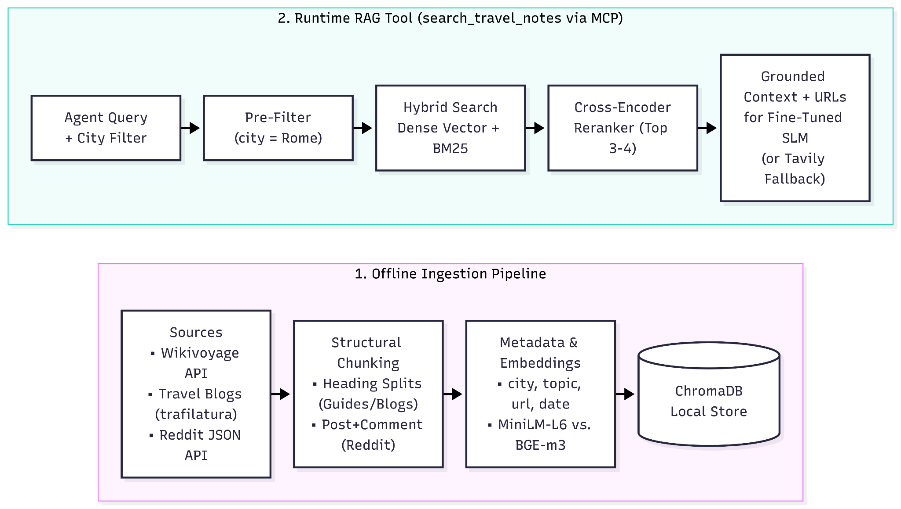

4. Agent, Tools and MCP Server
4.1. Role of the agent
Gate5 uses a single agent: a Python controller that runs each conversation turn, uses the SLM to understand the user, choose places and write the answer, and calls a small set of tested Python tools for facts (places, guide passages, schedule checks). These tools are exposed through a FastMCP server.
Principle: the model decides what to do; the tools and the validator decide what is true.
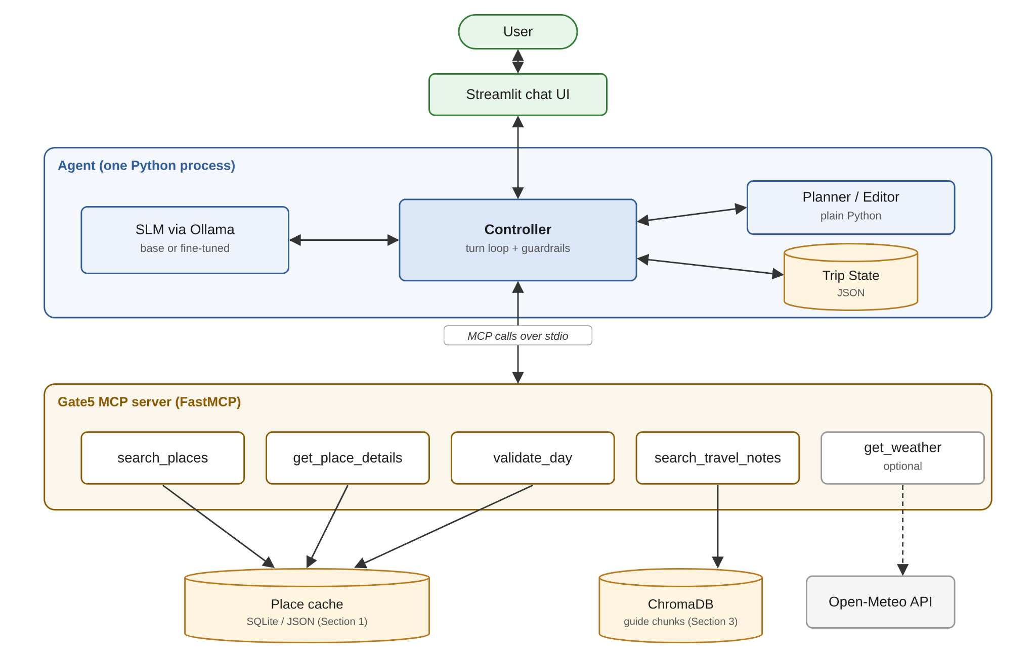

4.2. Decisions made by the agent

Decision | Possible outcomes | Golden cases
Intent: what kind of message is this? | New trip, edit trip, guide question or out of scope | All
Missing information: can we act yet? | Ask one follow-up question (only city and duration are blocking) or continue with defaults | GD08
Realism: does the request fit at all? | If not, explain why and propose a feasible alternative | GD03
Tools: which ones to call and in what order | For example search_places, then planning, then validate_day | –
Selection: which places to use | Rank candidates, but only from those returned by search_places | GD01–GD02
Repair: what to do about validator issues | One repair attempt (swap, move or remove a stop), then show the plan with warnings or a shorter plan | GD04–GD05
Edit scope: what the change touches | Only the target day or time block; other days and pinned stops are locked | GD06–GD07
Insufficient results: what to do when tools find nothing | Broaden the search once, then say honestly that nothing suitable was found | GD09–GD10

The agent may never invent a place, ID, opening hours or price, show a plan that skipped validation, change parts of the plan the user did not ask to change, or present guide, blog or forum text as live information.

4.3. Tools exposed through MCP
The agent can call five tools through the MCP server. Each tool is a plain Python function with a fixed input and output, so it can be tested on its own and reused by any MCP client. The first four are needed for the core workflow; get_weather is added only if time allows.

Tool | Input ->Output | Data
search_places | City, interest tags, category, indoor, name, nearby location → candidate places (provider, provider_id, name, coordinates, hours_status, est_visit_minutes, source_url) | Place cache (Section 1)
get_place_details | provider, provider_id, date → full place record and opening hours for that date, or "not verified" | Place cache
validate_day | Date, pace, ordered stops with times → ok / not ok and a list of issues | Place cache + Python rules
search_travel_notes | City, query, topic → passages with sources, or "insufficient_local_context" | ChromaDB (Section 3)
get_weather (optional) | City, dates → forecast, or "unavailable" | Open-Meteo

validate_day checks for unknown places, overlapping stops, too little time to walk between stops (a distance-based estimate), visits outside known opening hours, and too many stops for the chosen pace. Places with unknown opening hours receive an "hours not verified" warning instead of a guess.
Building a day and applying an edit (build_day, apply_edit) remain internal Python functions in the first version, because only the agent uses them and they modify the Trip State.
4.4. How the tools are exposed through MCP
The tools are first written and unit-tested as normal Python functions. A short mcp_server.py file then registers them with FastMCP (@mcp.tool()), so the server is only an adapter with no business logic. The controller starts the server as a subprocess over stdio, reads each tool's JSON Schema with list_tools(), passes these schemas to the SLM, and runs the selected tools with call_tool(). MCP Inspector is used to test the tools manually. If the SLM's tool calling proves unreliable (to be tested), the controller follows a fixed tool sequence for each intent, while the tools are still called through MCP.
4.5. Guardrails enforced in code
- Allow-list: any place produced by the SLM that was not returned by a tool in the current turn is dropped.
- Mandatory validation: the controller always runs validate_day on new or changed days.
- Edit locality: after an edit, the old and new plans are compared; if anything outside the target changed, the edit is rejected.
- Honest labels: "hours not verified" and "estimated time" notes are added automatically from the validator's results.
- Limits: at most one repair attempt, 8 tool calls per turn and 10 seconds per tool call.
4.6. Fine-tuned SLM in the agent
The agent gives the fine-tuned model (Section 5) narrow, checkable jobs: converting a user message into the intent and request JSON, producing correct calls to our tools, and answering only from returned sources. Training examples come from logs of the agent's own runs and from variations of the golden cases (the final test cases are kept separate). The model is selected by a single setting, so the base and fine-tuned models run through the same tools and tests and can be compared fairly.

4.7. Example: creating a plan, then editing it
This example follows one trip from the first request to a later edit, as shown in the diagram below.
First, the user asks for “2 days in Rome, history and food, relaxed pace”. The dates are missing, so the agent asks for them. It then calls search_places, picks the most suitable places and builds two days. When validate_day checks them, Day 2 has too little walking time between two stops and one place with unknown opening hours. The agent fixes the timing once and shows the itinerary, with the unknown hours marked “hours not verified” and a link for each place.
Next, the user asks: “Keep the morning, but make the afternoon stop indoors.” The agent looks for indoor places near the morning stop and replaces only the Day 1 afternoon. Day 2 is not touched. Day 1 is validated again, and the agent briefly explains what changed. If no suitable indoor place exists, the agent says so and suggests the closest option instead of inventing one.

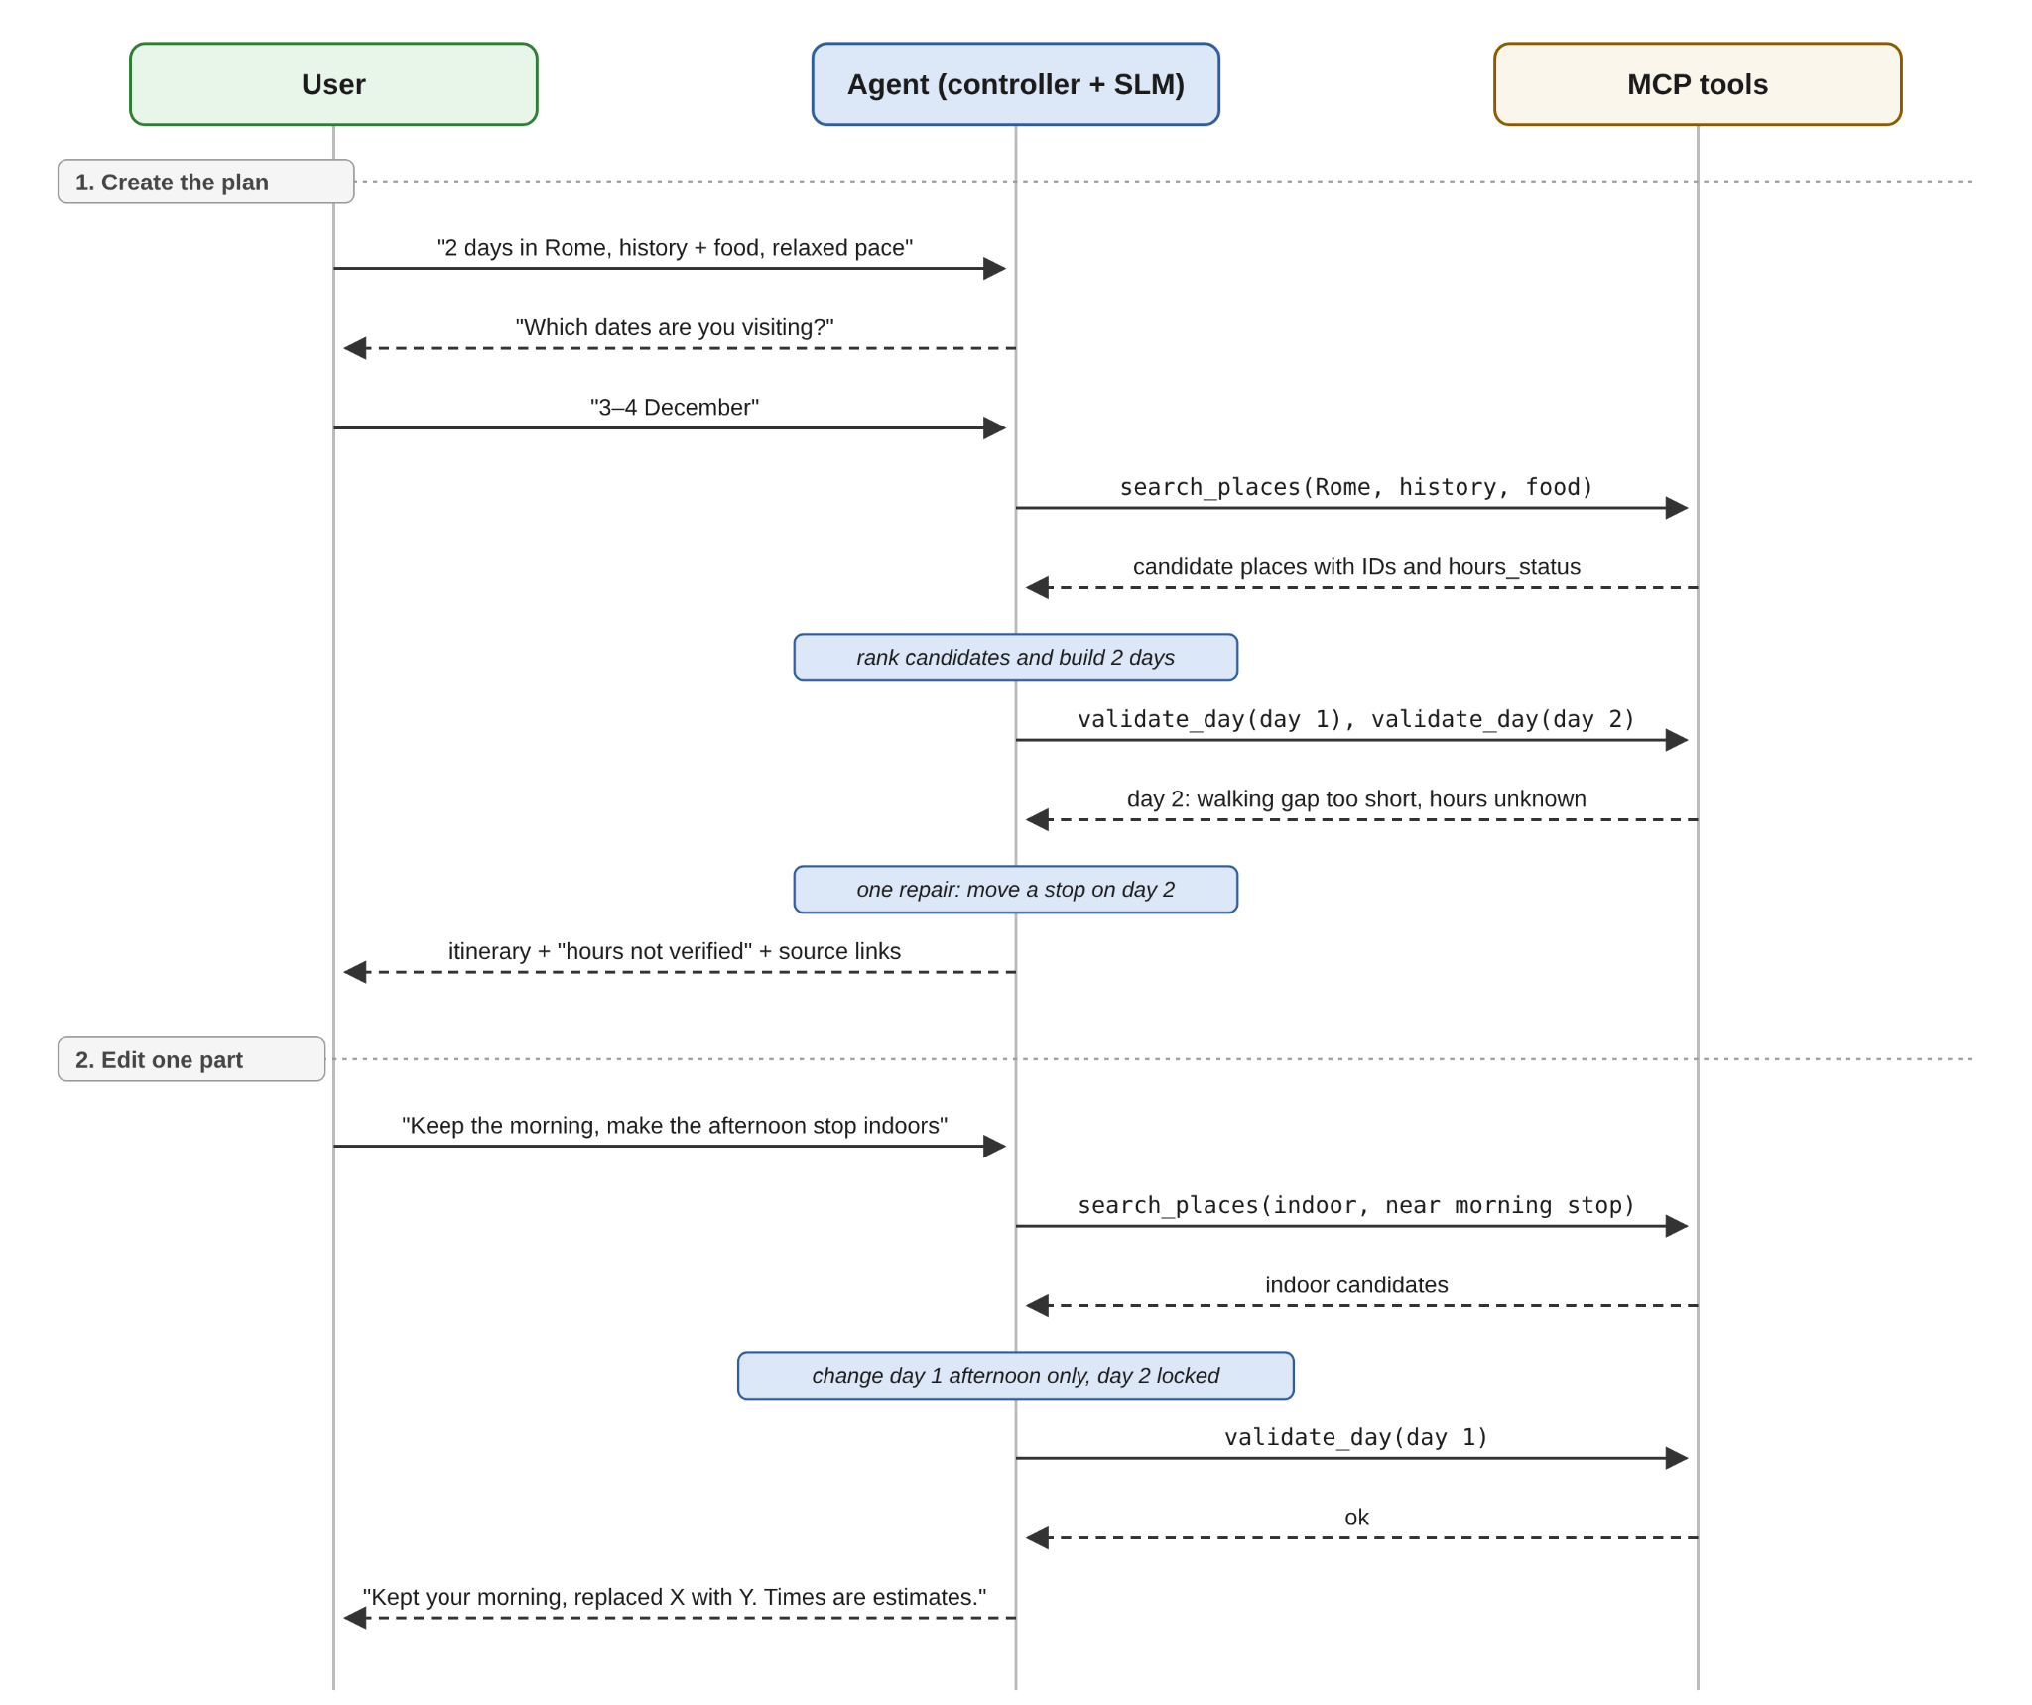

4.8. Evaluation of the agent
- Unit tests for every tool and validator rule, plus one scripted MCP client test.
- On the Golden Dataset (Section 2): intent accuracy, correct tool sequence, and whether unknown places or skipped validations occur.
- Edit locality: editing only the target day compared with regenerating the whole trip, counting unintended changes to other days.
- Base SLM compared with the fine-tuned SLM on the same test cases.

5. Model Choices

5.1. Candidate Models and Selection Rationale
For Gate5, we plan to use a Small Language Model (SLM) that can run locally, without relying on paid APIs. We chose this approach because our application focuses on a limited set of tasks, such as understanding travel requests, extracting preferences, selecting tools, and interpreting itinerary modifications.
We are considering two main models:
Model | Reason for considering
Qwen 2.5 3B Instruct | A relatively lightweight instruction-tuned model that we want to evaluate for structured output and following user instructions.
Llama 3.2 3B Instruct | A similarly sized alternative, allowing us to compare how different models handle the same travel-related tasks.
We chose these models mainly because of their relatively small size, local availability, and suitability for instruction-following tasks. Comparing two models of similar size should also help us evaluate their performance without introducing large differences in hardware requirements.
We plan to run both models locally using LM Studio, which we are already familiar with from our laboratory work. LM Studio also provides a local API that can be used to connect the selected model to our Python-based agent.
If our hardware allows it, we may also test Qwen 2.5 7B Instruct to see whether a larger model provides noticeable improvements.
The final model will be selected based on our evaluation results, focusing on request understanding, structured output accuracy, tool selection, itinerary modification, and response time.

5.2. Fine-Tuning Approach
After selecting a model, we plan to fine-tune it for the specific tasks required by Gate5.
We intend to use QLoRA/PEFT to adapt the model without updating all its parameters, reducing the computational resources needed compared to full fine-tuning.
Our training examples will focus on:
- Understanding travel requests and extracting structured trip information.
- Identifying the appropriate tools based on user requests.
- Interpreting itinerary modifications while preserving unaffected activities.
- Generating responses grounded in retrieved travel information, including source references.
For example, if a user asks to replace an activity on Day 2, the model should recognize that the request concerns an existing itinerary rather than generating a completely new trip.
We will prepare task-specific training examples and keep them separate from the evaluation data. Fine-tuning will be performed using a compatible training framework, while LM Studio will be used for local inference and testing.
We will compare the original model with its fine-tuned version to determine whether fine-tuning improves its performance on our tasks.

5.3. Model Evaluation
We will evaluate the candidate models using representative requests from our Golden Dataset, described in Section 2.
Our main evaluation criteria will be:
Criterion | What we evaluate
Request understanding | Correct extraction of destinations, trip duration, interests, budget, and pace
Structured output | Ability to generate valid JSON following the expected schema
Tool selection | Ability to identify the appropriate tool for a user request
Itinerary modification | Correct interpretation of requested changes and constraints
Response time | Time required to process a request
We will use the same test inputs and evaluation criteria for both candidate models to make the comparison fair.
First, we will compare the pretrained instruction-tuned models to select the most suitable candidate. After fine-tuning, we will repeat the evaluation to measure whether the adapted model performs better than the original version.
We will also consider the computational resources required to run each model locally.
Our goal is to select a model that reliably understands user requests and works well with our agent and tools, rather than simply choosing the largest available model.

6. Project Plan
We plan to develop Gate5 step by step, starting with the individual components and gradually connecting them into a working travel planning assistant. Our main goal is to have a functional prototype for the Week 12 progress review, leaving enough time for testing and improvements before the final presentation.

6.1. Weekly Timeline
Week | Planned Work | Expected Result
6 – Milestone 2 | Completed. | Milestone 2 documentation submitted.
7 | Collect place data and travel guides, prepare initial Golden Dataset cases, and set up candidate SLMs in LM Studio. | Initial datasets, travel documents, and locally running models.
8 | Implement place search functions, basic RAG retrieval, and the Python connection to the SLM. Start developing a simple itinerary generator. | Basic components working independently.
9 | Develop the agent, connect it to the SLM and place data, and implement basic itinerary validation. Compare the candidate models. | Initial itinerary generation and first model comparison results.
10 | Integrate RAG and MCP tools, implement itinerary state management, and add a simple chat interface. Start preparing training examples for fine-tuning. | First end-to-end prototype and initial training examples.
11 | Implement itinerary modifications, improve validation, and start evaluating RAG configurations. Continue preparing training examples. | Working itinerary generation and modification, with initial evaluation results.
12 – Progress Review | Test the application, fix major issues, and prepare a reproducible demo. Start a small fine-tuning experiment. | Functional prototype, documented GitHub progress, and possible initial fine-tuning results.
13 | Complete evaluation experiments, analyze failures, and compare the original and fine-tuned SLM if fine-tuning was successful. | Evaluation results, comparison tables, and documented limitations.
14 – Final Presentation | Finalize documentation and prepare the presentation and live demonstration. | Final report and working demo.

6.2. Planned Experiments
We plan to evaluate four main aspects of our system:
Experiment | Description
RAG Evaluation | Compare different chunking, embedding, and retrieval strategies to determine which configuration provides the most relevant information.
SLM Comparison | Compare Qwen 2.5 3B Instruct and Llama 3.2 3B Instruct based on request understanding, structured output, tool selection, and response time.
Itinerary Validation | Evaluate how well the system detects scheduling conflicts, invalid places, and other itinerary issues.
Adaptive Replanning | Test whether the system can modify an activity while preserving the unaffected parts of the itinerary.
We will use the Golden Dataset to evaluate the system consistently and record both successful results and failures.
If time and computational resources allow, we may also experiment with fine-tuning the selected SLM and compare its performance with the original model.
Our priority is to complete the core itinerary generation and modification features before focusing on optional improvements.

